The Attorney General of California has prepared the following title and summary of the chief purposes and points of the proposed measure:

SHALL THE U.S. GOVERNMENT FULLY FUND HEALTHCARE FOR VETERANS? INITIATIVE - Ask voters to express opinion whether the U.S. government should be required to fund the Department of Veterans Affairs fully to ensure that all eligible veterans receive quality and accessible healthcare. Summary of estimate by Legislative Analyst and Director of Finance of fiscal impact on state and local government: The measure would have no direct fiscal effect. (Initiative 07-0073.)

NOTICE TO THE PUBLIC
THIS PETITION MAY BE CIRCULATED BY A PAID SIGNATURE GATHERER OR A VOLUNTEER. YOU HAVE THE RIGHT TO ASK.

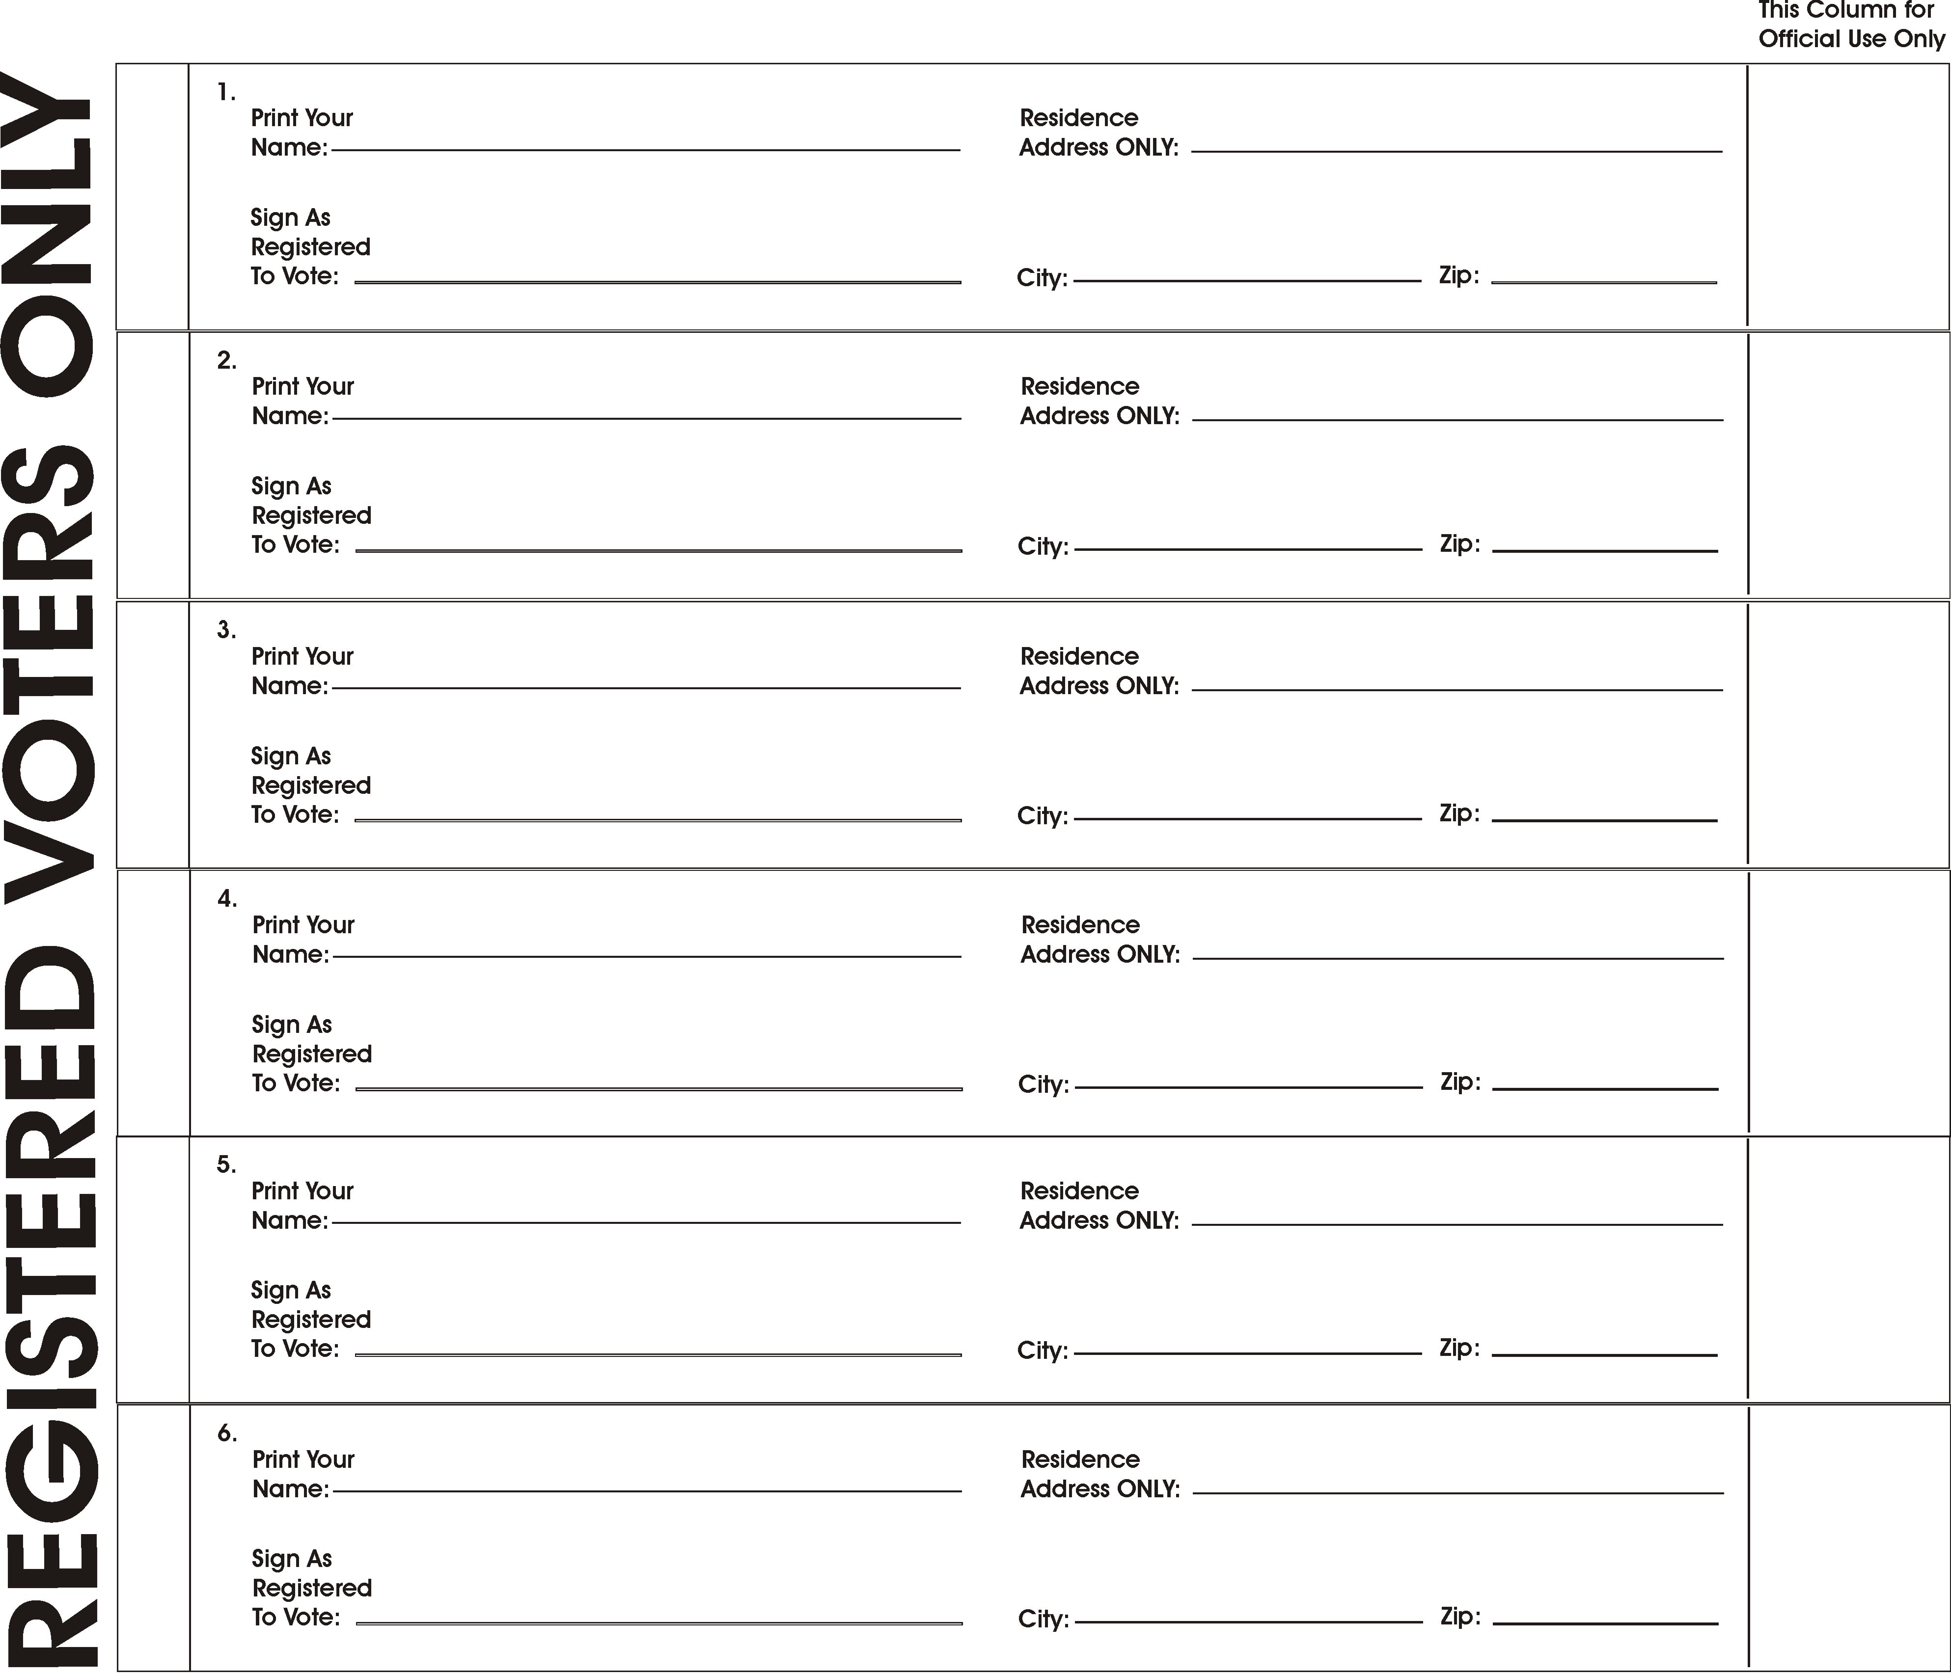

DECLARATION OF CIRCULATOR

I, ______________________, am registered to vote in the County (or City and County) of ______________________ or am qualified to register to vote in California. My residence address is _____________________________________. I circulated this section of the petition and witnessed each of the appended signatures being written. Each signature on this petition is, to the best of my information and belief, the genuine signature of the person whose name it purports to be. All signatures on this document were obtained between the dates of ________ and ________. I declare under penalty of perjury under the laws of the State of California that the foregoing is true and correct.
Executed on _____________, _______, at _________________________________________________
(Month & Day) (Year) (Place of signing)

___________________________________________
(Complete signature indicating full name of circulator)

